1



**PLAN FORMULA NOTES (NETWORK THEORY)**

# Basic Concepts

**Current:** Electric current is the time rate of change of charge flow.

i  dq

dt

(Ampere)

* ge transferred between time t0 and t

t

q   idt

t0

**Sign Convention:** A negative current of -5A flowing in one direction is same as the current of +5A in opposite direction.

**Voltage:** Voltage or potential difference is the energy required to move a unit charge through an element, measured in volts.

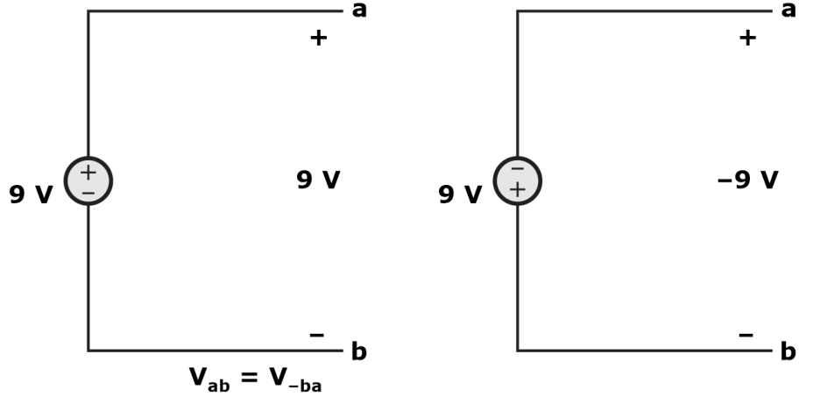

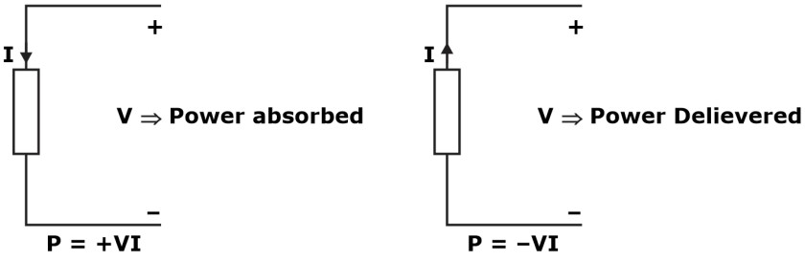**Power:** It is time rate of delivering or absorbing energy.

* Law of conservation of energy must be obeyed in any electric circuit.
* Algebraic sum of power in a circuit, at any instant of time, must be zero.

i.e. ∑P = 0

##### Circuit Elements:

**Passive element:** If it is not capable of delivering energy, then it is passive element. Example: resistor, inductor and capacitor.

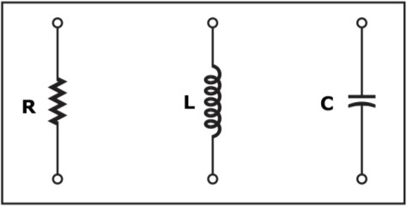

**Active element:** If an element is capable of delivering energy independently, then it is called active element. Example: Voltage source and current source.

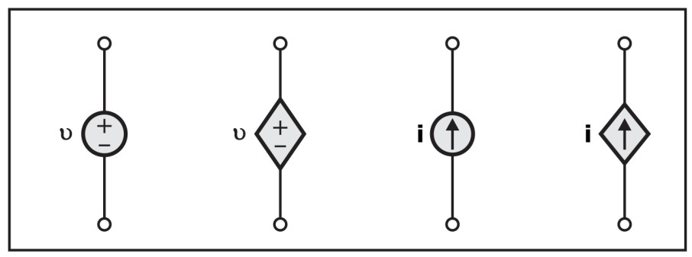

**Linear and Non-linear elements:** If voltage and current across an element are related to each other through a constant coefficient then the element is called as linear element otherwise it is called as non-linear.

**Unidirectional and Bidirectional:** When element's characteristics are independent of direction of current then element is called bi-directional element otherwise it is called as unidirectional.

* + R, L & C are bidirectional
  + Diode is a unidirectional element.
  + Voltage and current sources are also unidirectional elements.
  + Every linear element should obey the bi-directional property but vice versa as is not necessary.

**Resistor:** Linear and bilateral (conduct from both direction)

* + In time domain: V(t) = I(t)R
  + In s domain: V(s) = RI(s)

R  l ohm A

* + l = length of conductor, ρ= resistivity, A = area of cross section
  + Extension of wire to ‘n’ times results in increase in resistance:

R'  n2R

* + Compression of wire by ‘n’ times results in decrease in resistance:

R'  R

n2

**Capacitor:** All capacitors are linear and bilateral, except electrolytic capacitor which is unilateral.

* + - Time Domain:

i(t) 

CdV(t) dt

V(t)  1

C

t

⇩ i(t)dt



* + - In s-domain:

I(s) = s CV(s), V(s) = 1

sC

I(s)

* + - Capacitor doesn’t allow sudden change of voltage, until impulse of current is applied.
    - It stores energy in the form of electric field and power dissipation in ideal capacitor is zero.
    - Impedance:

Zc =-jXc Ω & Xc = 1

C

; Xc → Capacitive reactance;  = 2  f

##### Inductor:

Linear and bilinear element

* + - Time Domain:

V(t) = L di(t)

dt

1 t

i(t)   V(t)dt

L

◎

* + - Impedance**:**

ZL = j XL Ω & XL = L

* + - n s-domain**:** V(s) = sL I(s)

I(s) = 1 V(s)

sL

* + Inductor doesn’t allow sudden change of current, until impulse of voltage is applied. It stores

energy in the form of magnetic field.

* + Power dissipation in ideal inductor is zero.

|  |  |  |  |  |  |
| --- | --- | --- | --- | --- | --- |
| **FORMULAS FOR THE BASIC CIRCUIT COMPONENTS** | | | | | |
| CIRCUIT ELEMENT | IMPEDANCE | | VOLT- AMP EQUATIONS | | ENERGY  (dissipated on R or stored in L, C) |
| Absolute Value | Complex form | instantaneou s values | RMS values for sinusoidal signals |
| RESISTANCE | R | R | V=iR | Vrms=lrmsR | E=lrms Rt  2 |
| INDUCTANCE | 2  fL | jωL | V  L di  dt | Vrms=lrmsx2  fL | E  1 Li2 2 |
| CAPACITANCE | 1  2fC | 1  jC | i  C dV  dt | V  Irms  rms 2fC | E  1 CV2 2 |
| **Notes:**  R- resistance in ohms, L- inductance in Henry, C- capacitance in farad, f – frequency in Hertz, t- time in seconds,  ≈ 3.14159,  ω = 2  f – angular frequency j – imaginary unit (j2=-1)  Euler’s formula: ejx =cosx + jsinx | | | | | |

|  |  |  |  |  |
| --- | --- | --- | --- | --- |
| **EQUATIONS FOR SERIES AND PARALLEL CONNECTIONS** | | | | |
| CIRCUIT ELEMENT | SERIES CONNECTION | | PARALLEL CONNECTION | |
| RESISTORS |  | Rseries=R1+R2+… |  | *R*  1  *parallel*  1 1    *R*  *R*    1 2  |
| INDUCTORS |  | Lseries=L1+L2+… |  | *L*  1  *parallel*  1 1    *L*  *L*    1 2  |
| CAPACITORS |  | *C*  1  *series*  1 1    *C*  *C*    1 2  |  | *Cparallel*  *C*1  *C*2  *C*3... |

|  |  |
| --- | --- |
| **Rules of series** | **Rules of parallel** |
| Veq = V1 + V2 + V3 | ieq = i1 + i2 + i3 |
| Req = R1 + R2 + R3 | Req  1  1  1  1  R1 R2 R3 |
| Ceq = 1  1  1  1  C1 C2 C3 | Ceq = C1 + C2 + C3 |

|  |  |  |  |  |
| --- | --- | --- | --- | --- |
| **CALCULATIONS OF EQUIVALENT RLC IMPEDANCES** | | | | |
| CIRCUIT CONNECTION | COMPLEX FORM | | ABSOLUTE VALUE | |
| Black text on a white background  Description automatically generated  Series | Z=R+jωL+ | 1  jC | Z  | R2  (L  1 )2  C |
| Diagram, schematic  Description automatically generated  Parallel | Z  1  1  1  R jL | * jC | Z  | 1  1  1 2  R2  C  L     |

##### Faraday’s Law of electromagnetic induction:

* + - If a flux linking a coil varies as a function of time then an emf is induced between its terminals (statically induced emf).

•

V  N d

dt

* + - So,

N Li

Also,

### V  L di

dt

|  |  |
| --- | --- |
| L  | N |
| i |

##### A screenshot of a computer Description automatically generated with medium confidence(Δ – γ) And (γ – Δ) Transformations:

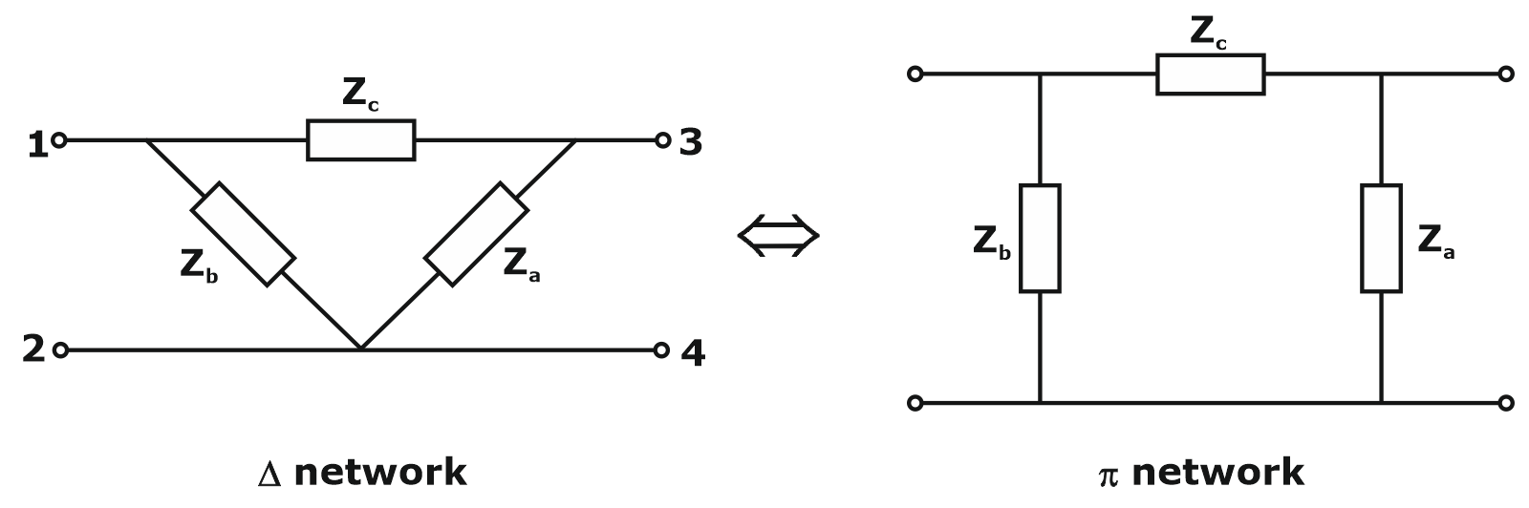

**Δ – γ Transformation:**

|  |  |
| --- | --- |
| Z1  | Zb Zc |
| Za  Zb  Zc |

|  |  |
| --- | --- |
| Z2  | Za Zc |
| Za  Zb  Zc |

|  |  |
| --- | --- |
| Z3  | Za Zb |
| Za  Zb  Zc |

##### γ → Δ Transformation:

|  |  |
| --- | --- |
| Za  | Z1Z2  Z2Z3  Z1Z3 |
| Z1 |

|  |  |
| --- | --- |
| Zb  | Z1Z2  Z2 Z3  Z1  Z3 |
| Z2 |

|  |  |
| --- | --- |
| Zc  | Z1Z2  Z2 Z3  Z1Z3 |
| Z3 |

**Bridge:**

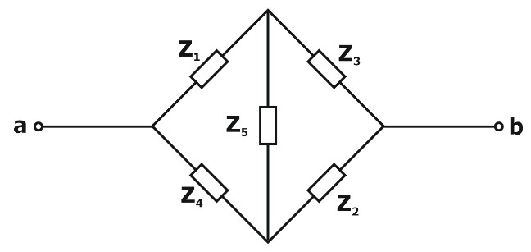

Z1 = |Z1| ∠θ1 Z2 = |Z2| ∠θ 2 Z3 = |Z3| ∠θ 3 Z4 = |Z4| ∠θ 4 for balance, Z1Z2 = Z3Z4

### 

| Z1 || Z2 |  | Z3 || Z4 |

and

1  2  3  4

##### Source Transformation:

It is a process in which a voltage source connected in series with resistance can be converted into a current source connected in parallel with the same resistor and vice-versa.

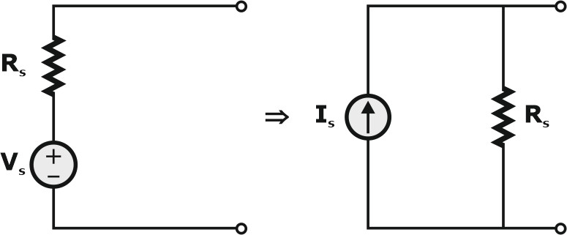

Where,

Vs = IsRs

then

|  |  |
| --- | --- |
| Is  | Vs |
| Rs |

##### Voltage Source:

* In a practical voltage source, there is small internal resistance, so the voltage across the element varies with respect to current.

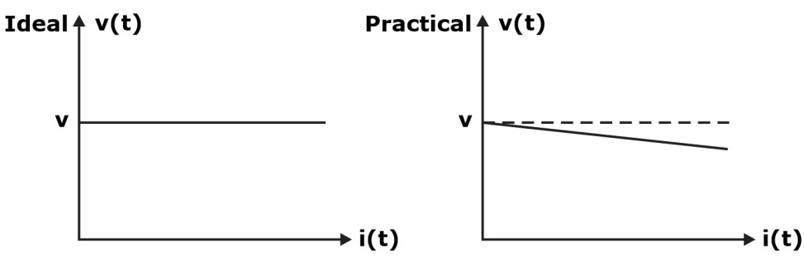

* Ideal voltmeter, RV is infinite (Internal resistance)

##### Current Source:

* In practical current source, there is small internal resistance, so current varies with respect to the voltage across element.

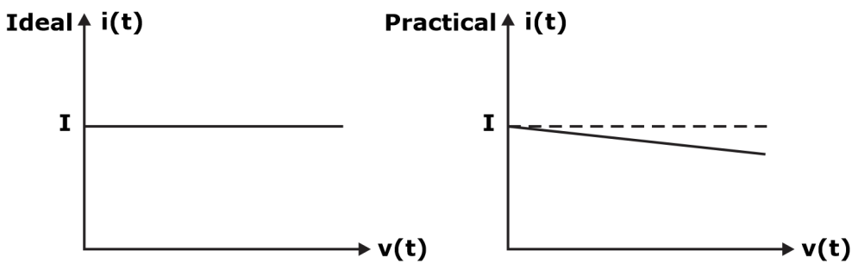

* Ideal Ammeter, Ra is 0 (Internal resistance)
* Internal resistance of voltage source is in series with the source.
* Internal resistance of ideal voltage source is zero.
* Internal resistance of current source is in parallel with the source.
* Internal resistance of ideal current source is infinite.

**Independent source:** Voltage or current source whose values doesn’t depend on any other

parameters.

* **Example:** Generator

**Dependent Source:** Voltage or current source whose values depend upon other parameters like current, voltage.

**Lumped Network:** Network in which all network elements are physically separable is known as lumped network.

**Distributed Network:** A network in which the circuit elements like resistance, inductance etc, are not physically separable for analysis purpose, is called distributed network. Example: Transmission line.

# Mesh and Nodal Analysis

##### Kirchhoff’s current law (KCL):

KCL states that the algebraic sum of the currents entering a node or meeting at a point is zero.

It is based on law of conservation of charge.

##### Kirchhoff’s voltage law:

KVL states that the algebraic sum of all the voltages in a closed loop is zero. It is based on the law of conservation of energy.

##### Mesh Analysis:

* Path – A set of elements that may be traversed in order, without passing through the same node twice.
* Loop – A closed path
* Mesh – A loop that does not contain any other loop within it.
* Planar Circuit – A circuit that may be drawn on a plane surface in such a way that there are no branch crossovers
* Non-Planar Circuit – A circuit that is not planar, i.e. some branches pass over some other branches (cannot use Mesh Analysis)
* Number of equations required to solve the circuit with the help of mesh analysis are:

e  b n  1

Where,

b = number of branches n = number of nodes

##### Nodal Analysis:

* Identify the total number of nodes in the circuit.
* Assign the voltage at each node and one of the nodes is taken as the reference node and the potential of reference node is equal to the ground potential.
* Develop KCL equation for each non – reference node.
* By solving KCL equation, find the node voltages.

The total number of equations required to solve the network by using nodal analysis are:

e = N – 1

# Circuit Theorem

##### Thevenin’s Theorem:

Any linear network can be replaced by an independent voltage source in series with an impedance such that the current voltage at the terminal is unchanged.

##### Norton’s Theorem:

Identical to Thevenin’s statement except that the equivalent circuit is an independent current source

in parallel with Zs = RTh.

##### Superposition Theorem:

If a number of voltage or current sources are acting simultaneously in a linear bidirectional network, the resultant response in any branch is the algebraic sum of the responses that would be produced in it, when each source acts alone replacing all other independent sources by their internal resistances.

##### Maximum Power Transfer Theorem: For DC Circuits:

*RTh*  *RL*

*P*max  *Th*

*V* 2

4*RTh*

**For AC Circuits:**

1. When complete ZL load is varying, i.e. RL & XL is varying, then the condition for

 *Z*

*

maximum power to be transferred to the load is

*ZL S*

1. When only RL is varying & XL is fixed, then the condition for maximum power to be

transferred to the load is

RL =

1. When only RL is varying and XL = 0, then the condition for maximum power to be

R + X +X

2

S S



L



2

transferred to the load is

*RL*  *ZS*

1. When only XL is varying and RL is fixed, then the condition for maximum power to be transferred to the load is XL = - XS.

Pmax = Th

V2

4RTh

##### Millman’s Theorem:

As per Millman’s Theorem,

± V1 ± V2 ± V3 + ± Vn

V= R1 R2

1 + 1

R1 R2

## R=

R3 Rn

## + 1 +......................+ 1

R3 Rn

## 1

1 + 1

R1 R2

## + 1 +......................+ 1

R3 Rn

Mathematically, it is written as

 VK

n

V= K=1 RK

n

 1

K=1 RK

R= 1

n

 1

K=1 RK

|  |  |
| --- | --- |
| **Average Power**  PAvg = Vm  Im cos(  )  2 2  = VrmsIrms cos(  ) | **Power Factor**  PF= cos (  )   =  v -  i |
| **Reactive Power**  Q = VrmsIrms sin(  )  Measured VARs (Volt Ampere Reactive) P2 + Q2 = (VrmsIrms)2 | **True Power**  P = I2 R |
| **Apparent Power (s)**  S= VrmsIrms VA |  |
| S = P + j Q |  |
| S = I2 Z |  |

|  |  |
| --- | --- |
|  |  |

# TRANSIENT ANALYSIS

##### DC Transients:

For Inductor,

iL(0-) = iL(0) = iL(0+)

Where,

iL(0-) = current at instant just before switch operation iL(0) = current at exact instant of switch operation

iL(0+) = current at instant just after the switch operation. For capacitor,

Vc(0–) = Vc(0) = Vc(0+)

##### Source free circuits:

**Source free RL circuit:**

i(t)  I0 e

− t 

Where,  is time constant

V (t)= -I Re-Rt L

L

0

V (t)  I ReRt L

R

0

τ= L Req

Energy stored in inductor:

1 2

WL (t)= 2 Li

###  W (t)  1 L I

e Rt L 2

L 2 0

⇒

W (t)  LI e

1

2  2t 

L

2

0

W (t)  LI 

1

2

1  e 

2t 

R

2

0

##### Source Free RC circuit:

V (t)  V et 

c

0

Where,  = time constant

i (t)   e

V

0

t RC

c

R

iR (t)  0

V et RC

R

⧫  RC

Energy stored in capacitor:

### W (t)  1 CV2

c

###  1 CV

2

et  2

2 0

W (t)  CV e

1

2 2t 

c

2

0

W  (t)  CV 

1

2

1 e 

2t 

R

2

0

##### Circuits with Source:

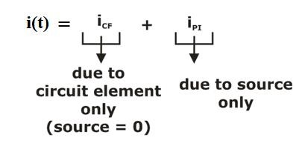**RL circuit with source:**

General equation 

###  where,   L 

 

###  

i(t)  i() [i(0)  i()] et 

R

##### RC circuit with source:

Vc (t)  VCF (t)  VPI(t)

where,  = RC

##### Second Order System: Series RLC system:

V (t)  V ()  

c

V (0)  V () e

t 

c

c

c

s1, 2   2L 

-R

 R 2

 2L   LC

1

 

For Underdamped case:

### i(t)=(C cosβt+C sinβt)e-αt

1 2

Time constant,

1  R 2

LC  2L 

-



τ= 1 = 2L

α R

damping frequency,

ωd =

ω =

d

1

LC

 R

1 -

C 

2

 2



L 



→  natural frequency;

ω =

n

1

LC

ξ= R

2

C

L

##### Parallel RLC circuit:

s1, 2 = 2RC ±

-1



 2RC  - LC

1

2

1





For Underdamped case:

V(t) = (C1 cost + C2 sint)e-t

where, Time constant,

τ= 1 =2RC

α

ωd =

1  1

2

LC  2RC 

-



ωd =

1-

1

 1

LC

 2R

L 

C 

2



Where,

##### AC Transients:

ωn = ;

; ωd =ωn

1-ξ2

1

LC

 

1

2R

L

C

i (t)  Vm sin ωt  θ  α *e*

|Z| 0

* Rtto 

L

Vm sin t    

### | Z |

For transient free response:

t0 +  –  = 0

t0 =  – 

t0

###  tan1 L  

R

# Two-port Networks

The six parameters derived from two port network are as follows:

* + Z Parameters
  + Y or Z-1 Parameters
  + h Parameters
  + g or h-1 Parameters
  + ABCD or T Parameters
  + (ABCD)-1 or T-1 Parameters

##### Impedance parameter or Z – parameter or open-circuit parameter:

* Z parameter is also referred as open circuit parameters. V1 = f (I1, I2)

V2 = f (I1, I2)

Independent Variables are I1 & I2 Dependent variables are V1 & V2

* V1 = Z11I1 + Z12I2 V2 = Z21I1 + Z22I2
* Z Parameters for the symmetrical lattice network are

Za  Zb Zb  Za 

 2 2 

Z  Z



#### Z Z  Z

 b a a b 

####  2 2 

##### Admittance parameter or Y-parameter or short-circuit parameter:

* + Y parameter is also referred as open circuit parameters. I1 = f (V1, V2)

I2 = f (V1, V2)

Independent Variables are V1 & V2 Dependent variables are I1 & I2

* + I1 = Y11V1 + Y12V2 I2 = Y21V1 + Y22V2

##### Condition of Reciprocity and Symmetricity:

|  |  |  |
| --- | --- | --- |
| Parameter | Reciprocity | Symmetricity |

|  |  |  |
| --- | --- | --- |
| Z parameter | Z12 = Z21 | Z11 = Z22 |
| Y parameter | Y12 = Y21 | Y11 = Y22 |

All resistive circuits are reciprocal network and dependent source networks are non-reciprocal. In case of dependent source network, if Z12 = Z21 then the network will be reciprocal.

##### Hybrid parameter or h-parameter:

* + V1 = f (I1, V2) I2 = f (I1, V2)

Independent Variables are I1 & V2 Dependent variables are V1 & I2

* + V1 = h11I1 + h12V2 I2 = h21I1 + h22V2
  + Relation between h Parameters and Z or Y Parameters:

h11 

V2 0

V1 I1

####  1 

Y11

|  |  |
| --- | --- |
| h11  | 1 |
| Y11 |

h12 

I1 0

V1 V2

 Z12 

Z22

|  |  |
| --- | --- |
| h12  | Z12 |
| Z22 |

h21 

h22 

V1 0

I1  0

I1 V2

I1 V2

 Y21 

Y11

|  |  |
| --- | --- |
| h21  | Y12 |
| Y22 |

####  1 

|  |  |
| --- | --- |
| h21  | 1 |
| Z22 |

Y22

* + **Condition for Reciprocity:** h12 = –h21
  + **Condition for Symmetry:** Δh or |h| = 1 or h11h22 – h12h21 = 1

##### Inverse Hybrid parameter or g-parameter:

* + I1 = f (V1, I2) V2 = f (V1, I2)

Independent Variables are V1 & I2 Dependent variables are I1 & V2

* + I1 = g11V1 + g12I2 V2 = g21V1 + g22I2
  + **Condition for Reciprocity:** g12 = -g21
  + **Condition for Symmetry:** Δg = |g| = 1 or g11g22 – g12g21 = 1

##### Transmission parameter or ABCD parameter or T parameter:

* + V1 = f (I1, I2) V2 = f (I1, I2)

Independent Variables are I1 & I2 Dependent variables are V1 & V2

* + V1 = AV2 – BI2 I1 = CV2 – DI2
  + **Condition for Reciprocity:** ΔT = 1 or AD – BC = 1

##### Condition for Symmetry: A = D

**INTERCONNECTION OF TWO PORT NETWORKS**

##### Diagram, schematic Description automatically generatedSeries Connection:

Z

 Z  Z

a b

[Z]  Z11a  Z11b



Z21a  Z22b

Z12a  Z12b 

Z22a  Z22b 

 

##### Parallel Connection:

a b

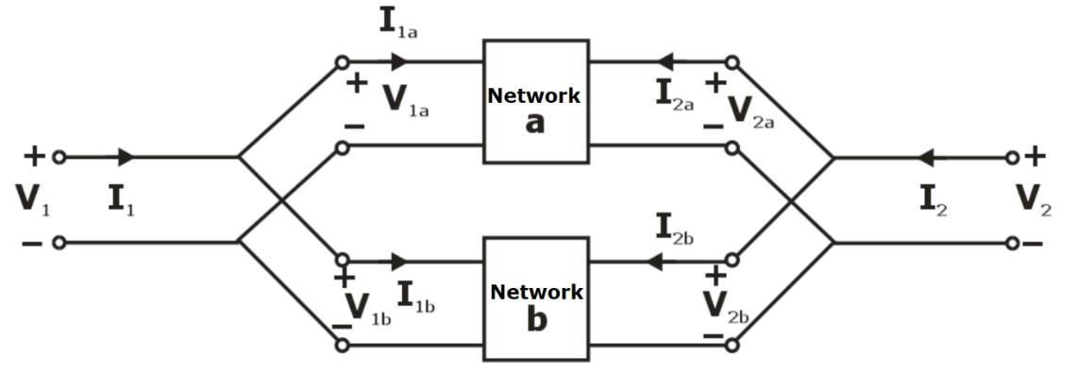

Y = Y + Y

[Y]=Y11a+Y11b



Y21a+Y21b

Y12a+Y12b 

Y22a+Y22b 

 

##### Series parallel Connection:

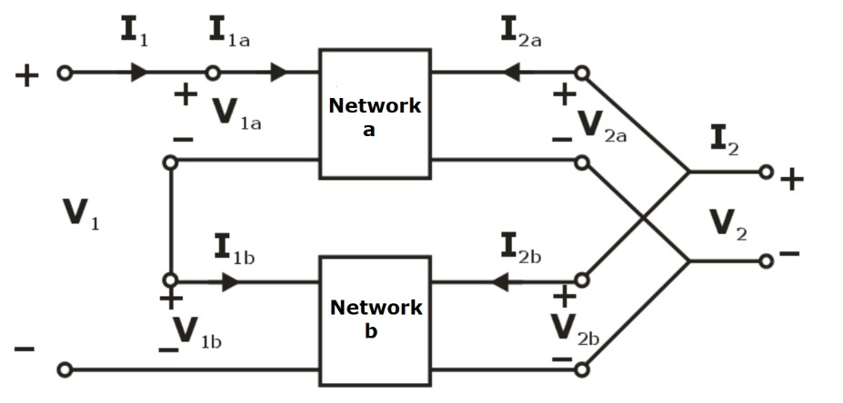

h

 h 

h

##### Parallel Series Connection:

a

b

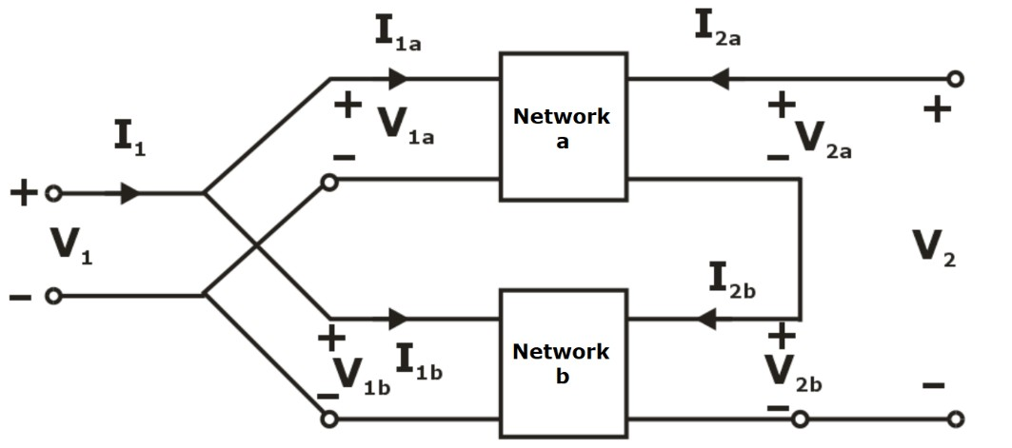

g = g + g

a b

##### Diagram, schematic Description automatically generatedCascade Connection:

[ABCD]Total  [ABCD]a [ABCD]b

##### Network Components:

**Transformer:**

4 terminal or 2-port devices.

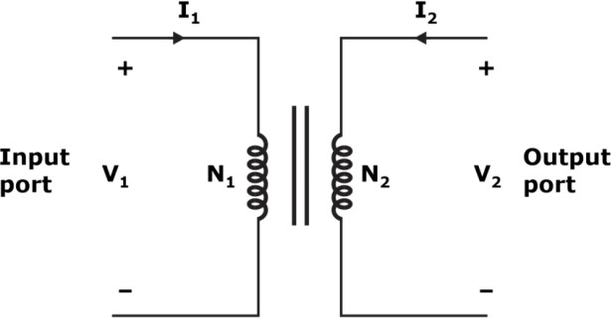

* + - N1 > N2 : Step down transformer

V1  N1 V2 N2

* + - N2 > N1 : Step up transformer

I1  N2 , Where N1 = K → Turns ratio.

I2 N1

* + - T  n 0 

N2

h   0 n

  0 1 / n

  n 0

   

* + - Transformer does not work as amplifier because current decreases in same amount power remain constant.

##### Diagram Description automatically generatedGyrator:

* + - R0 = Coefficient of Gyrator
    - V1 = R0 I2
    - V2 = R0 I2
    - If load is capacitive then input impedance will be inductive and vice versa.
    - If load is inductive then input impedance will be capacitive.
    - It is used for simulation of equivalent value of inductance.

##### For Series and Shunt elements:

**For Series element (I1 = –I2)**

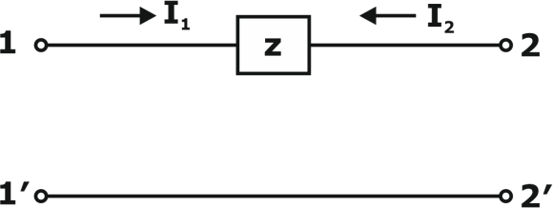

ABCD parameters can be defined by

A B  1 Z

C D 0 1

   

##### For Shunt element (V1 = V2)

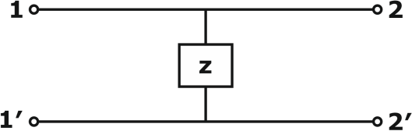

ABCD parameters can be defined by

A B

 1 0

    1 

C D

 1

Z 

# AC Circuits

Circuits driven by sinusoidal voltage and current sources are called ac circuits. Both sine and cosine come under sinusoidal sources.

##### Root Mean Square:

Vrms =

T V dt

1 T

2

0

Where, T is time period.

**Average value:**

V = 1 T Vdt

avg T 0

where, T is time period of equal.

##### Form factor:

It is the ratio of RMS value of waveform to the average value of waveform.

FF  RMS Value

Avg Value

##### Peak Factor:

It is the ratio of the max value of waveform to the RMS value of waveform.

PF  Max Value

RMS Value

##### Sinusoidal steady state analysis:

Conditions to compare the phases of two sinusoidal:

1. Both functions should be expressed either in sine or cosine.
2. Both functions should have to written with positive amplitude.
3. Both functions should have same frequency.

##### Representation of Circuit elements:

|  |  |  |  |
| --- | --- | --- | --- |
| **Time Domain** | | **Frequency domain** | |
|  | v = Ri | V = RI |  |
|  | v = L di  dt | V = jωLI |  |
|  | v = 1  idt C | v = 1 I  jC |  |

**Series RL Circuit:**

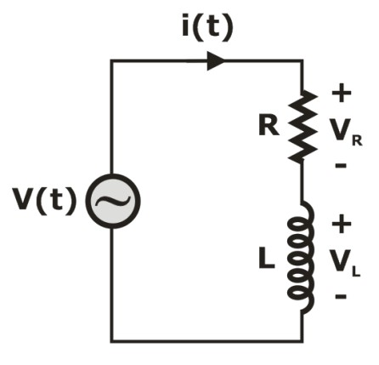

Z  R  jXL

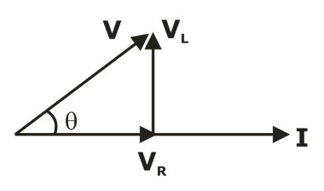Phasor:

V 

⇒

V2  V2

R L

❑  tan1 XL

R

❑  tan1 VL

VR

Pavg = VRMS IRMS cos

cos  VR (lagging )

V

##### Diagram, schematic Description automatically generatedSeries RC Circuit:

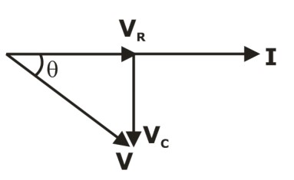Phasors:

⇒

V  V2  V2

R C

❑   tan1 VC

VR

|  |  |
| --- | --- |
| ❑   tan 1 | XC |
| R |

→ leading

|  |  |  |
| --- | --- | --- |
| cos  | VR |  |
| V |
| Pavg = VRMS IRMS cos | | |

##### Diagram, schematic Description automatically generatedSeries RLC Circuit:

Z = R + j(XL  XC)

Phasor:

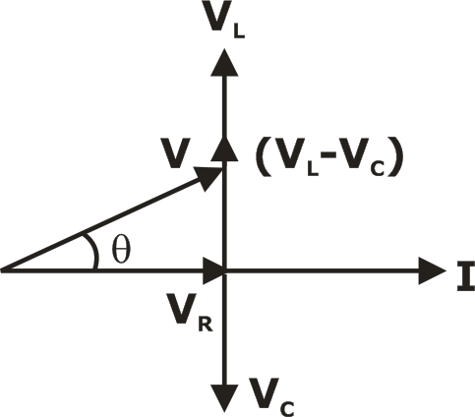

### V 

V  

2

R L C

V  V 

2

❑  tan1 VL  VC

R

❑  tan1 XL  XC

R

⇒

→ (lagging)

cos  VR

V

##### Series and Parallel Resonance:

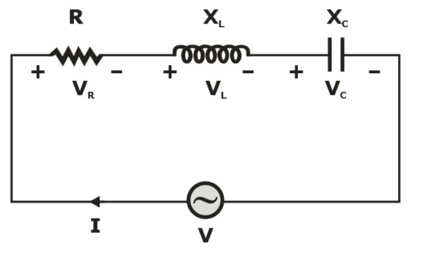 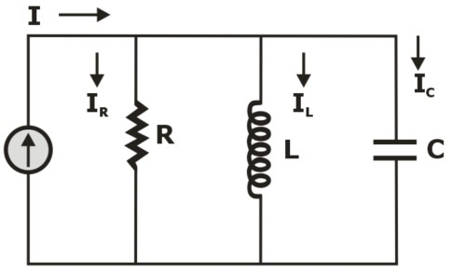

Z = R + jXL – jXC

Y  1  1

* jC

#### R jL

##### Variation of circuit parameters for series RLC with frequency:

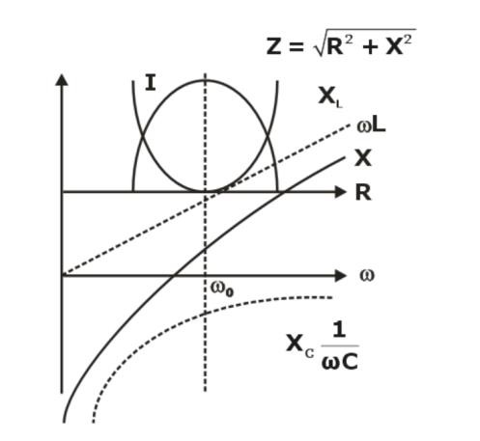

1. Reactance of the circuit is zero at the resonant frequency.
2. Impedance of the circuit reaches its minimum at the resonant frequency.
3. Current in a series resonant circuit is maximum at the resonant frequency.

⇒ 0 

1

LC

rad/sec or

f0  Hz

|  |  |  |
| --- | --- | --- |
| **Characteristic** | **Series Circuit** | **Parallel Circuit** |
| **Resonant Frequency (ω0)** | 1  LC | 1  LC |
| **Quality Factor** | 0L or 1  R 0RC | R or  RC   L 0  0 |
| **Bandwidth** | 0  Q | 0  Q |

# Magnetic Coupling Circuits

##### Self-Inductance:

Self-Inductance is the effect of change in the magnetic flux linking in the circuit due to change in current of the same circuit. It is denoted by ‘L’ and the unit is Henry.

V =L

di1

(According to Faraday’s Law)

induced 1 dt

L1 is the self-inductance corresponding to change in current i1,

Also, *L*  *N*

*d*11

1 1 *di*1

##### Mutual-Inductance:

Mutual inductance is the effect of change in magnetic flux linking in a circuit due to change in current of another circuit.

The voltage induced in the first coil due to current in it.

*V*  *N*

*d*11  *L*

*di*1

1 1 *dt*

1 *dt*

The voltage induced in the second coil due to current in the first coil.

*V*  *N*

*d*12  *M*

*di*1

2 2 *dt* 21 *dt*

##### Coefficient of Coupling:

The coefficient of coupling is defined as the fraction of the total flux that links the magnetic coil.

*K*  12

1

or *K*  21

2

 *L*  *N*111 ; *L*  *N* 22

1

2 LC

1 *i*1 2 2 *i*2

*M*12  *N*1

21 ; *M*

*i*2

21  *N*2

12

*i*1

*M*  *K L*1*L*2

##### Magnetically coupled coils in series connection:

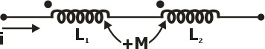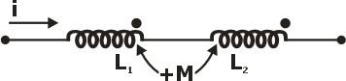or

For positive mutually connected series coil:

Leq =L1+L2 +2M

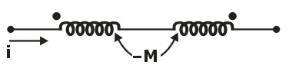

For negative mutually connected series coil:

Leq =L1+L2 -2M

**Magnetically coupled coils in parallel connection: Case-I:** Positive naturally connected parallel coil

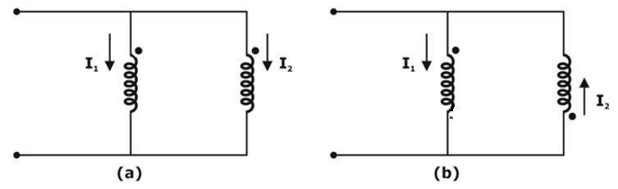

As current enters through dots in both the coils, they are positive mutually connected coils.

|  |  |
| --- | --- |
| Leq  | L1L2  M2 |
| L1  L2  2M |

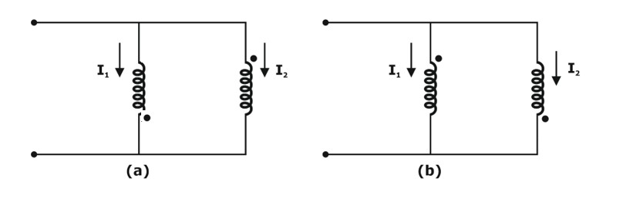**Case-II:** Negative mutually connected parallel coil

As current enters through dot in one coil and leaves through dot in another coil, they are negative mutually connected coil.

|  |  |
| --- | --- |
| Leq  | L1L2  M2 |
| L1  L2  2M |

##### *****